Git Challenges
- Resolve Merge Conflicts
  - Create a merge conflict intentionally (two users editing the same line).
  - Resolve the conflict and push the changes.
Solution:
I just created two files in two different branches with same file name. But minor difference in file content. I changed into tracking stage and commited the changes.
I tried to merge the two branch…That time I faced the merge conflict. There is no automation for resolve the conflicts. Need to work on manually, What we need to merge and all.
Important Note - If I have same file and same content in different branches that will merge automatically. There will be no issues or conflicts.
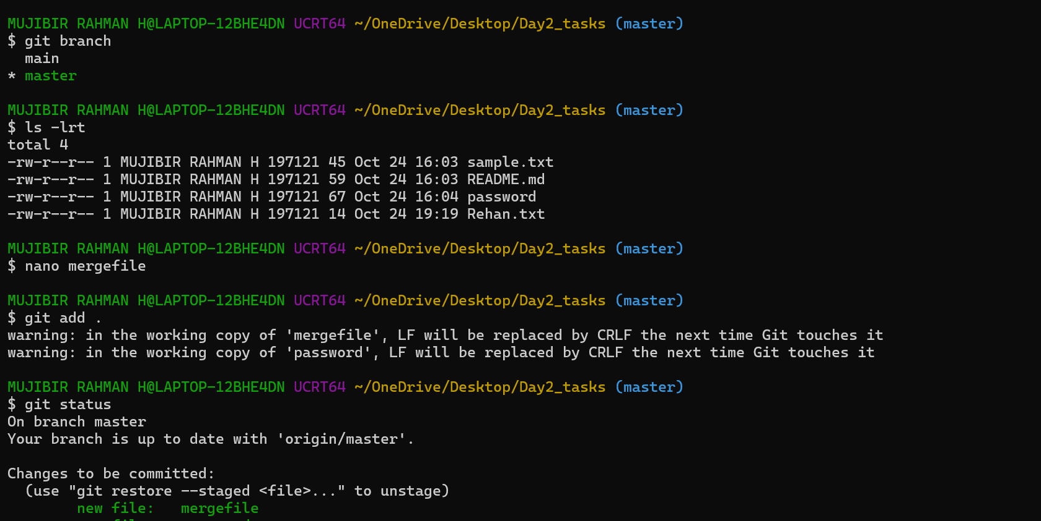
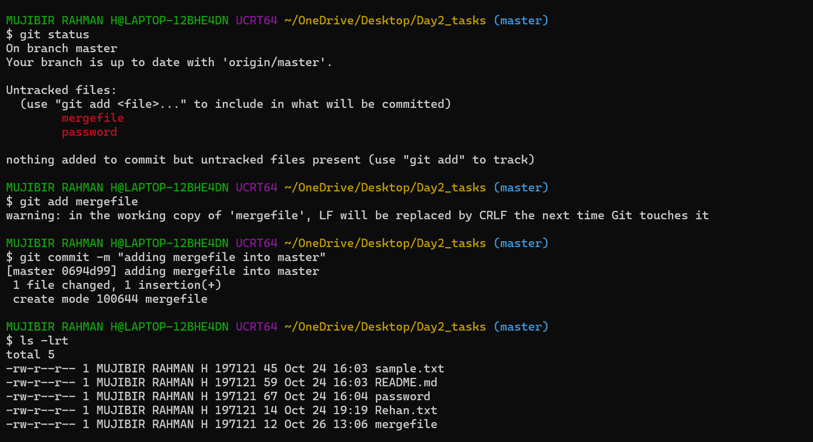
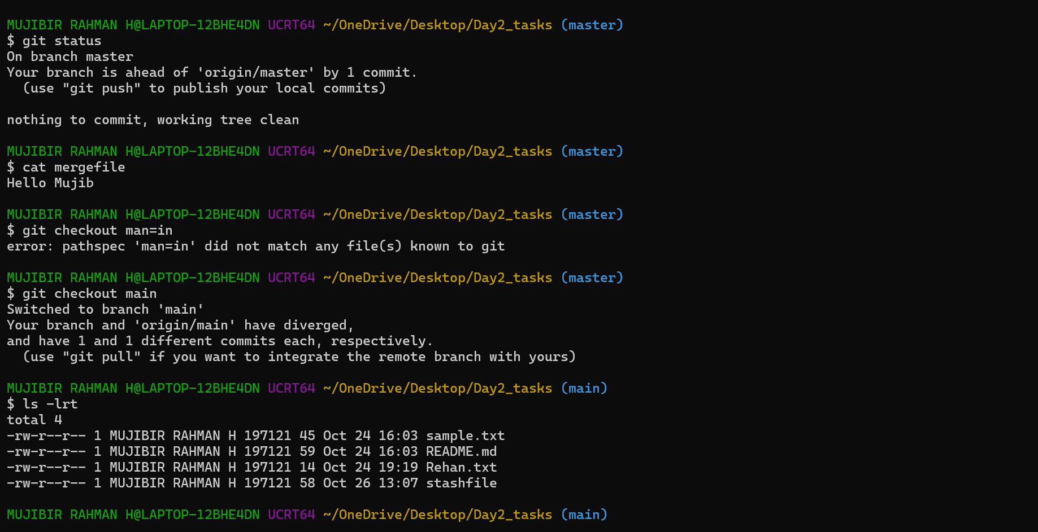
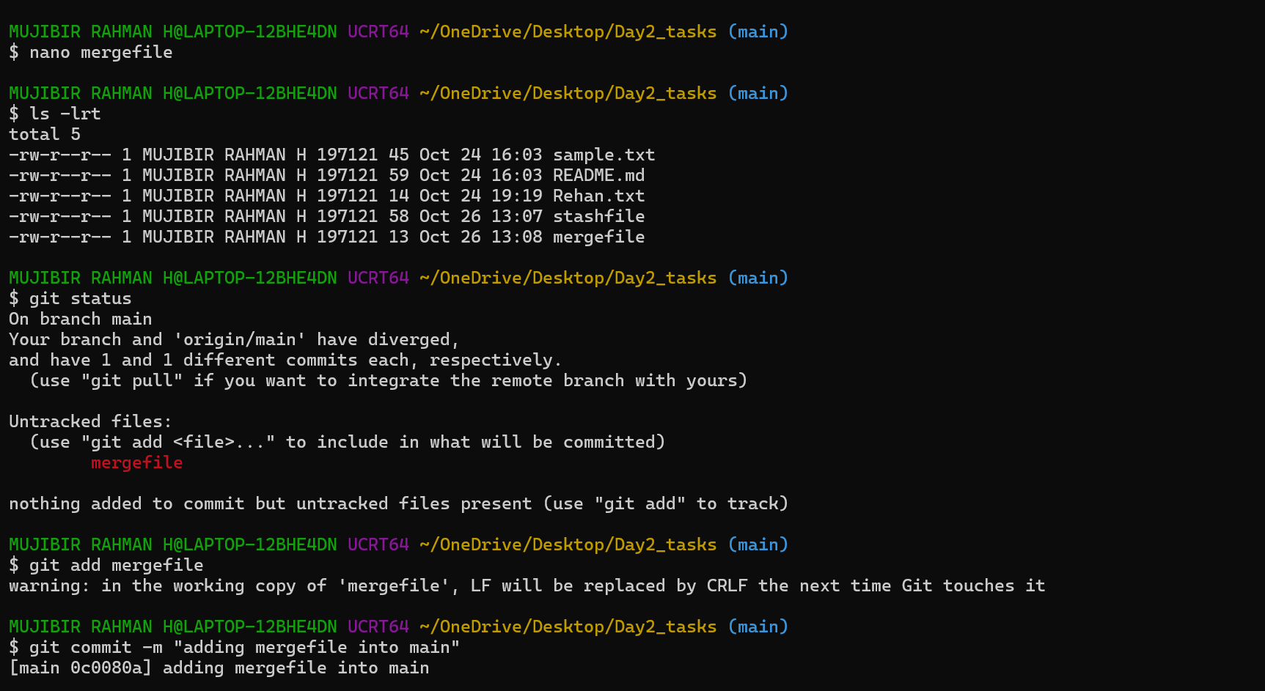
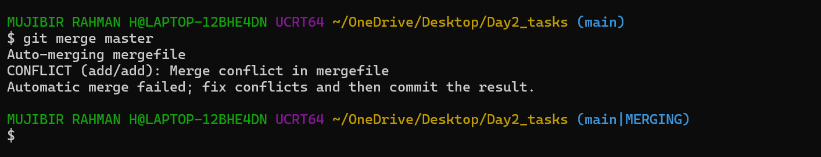
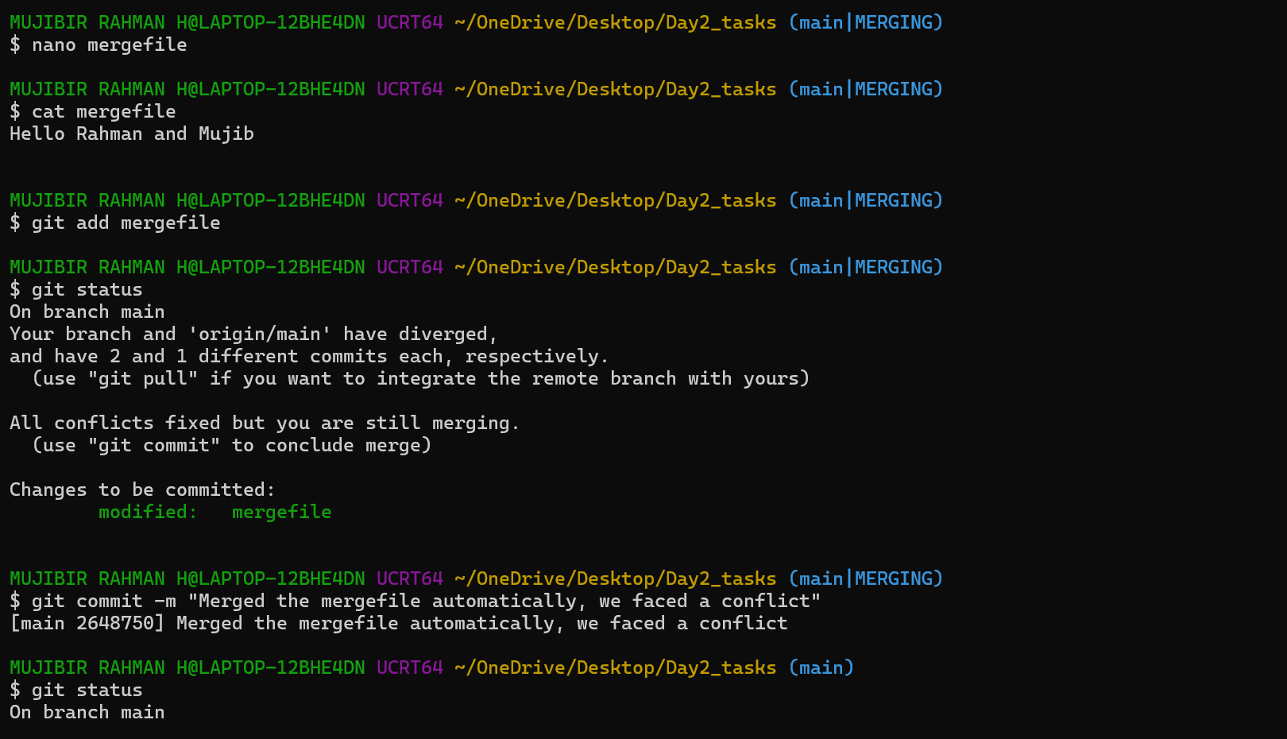
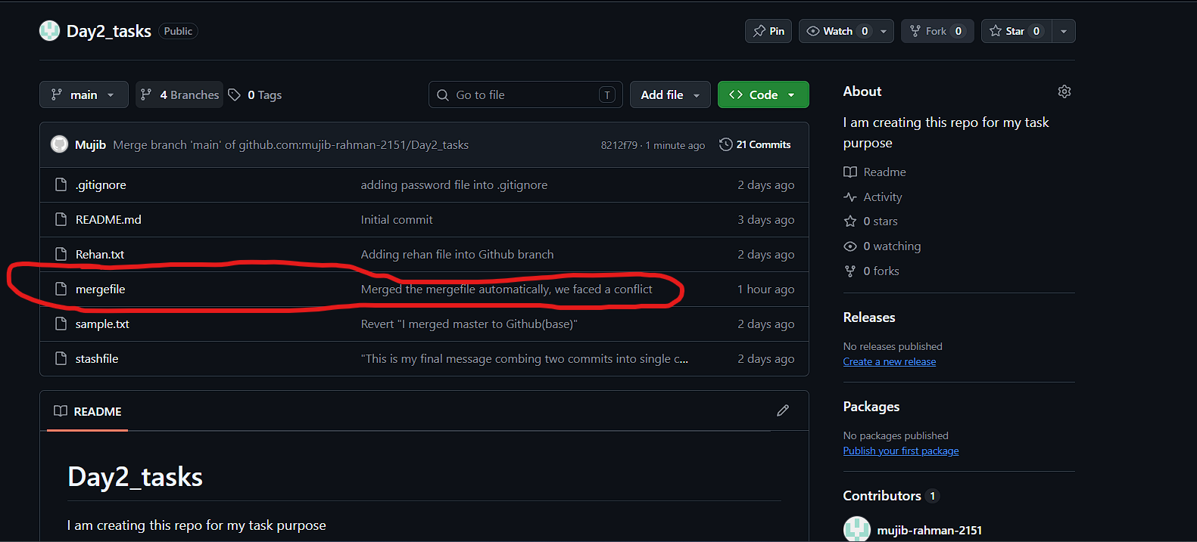
- Recover Deleted Branch
  - Delete a local branch and then recover it using the reflog.
Solution:
I just created one branch – test.
I just added one file into that branch.
I deleted the branch unknowingly, but our commit activity is still there in our logs. So, we can use this git reflog command to check.
If, we need to recover the branch or that file, We need to note down that commit id and execute this below command. It will help us to restore the changes.
git switch -c (c is indicating create) < new branch name> <commit_Id>
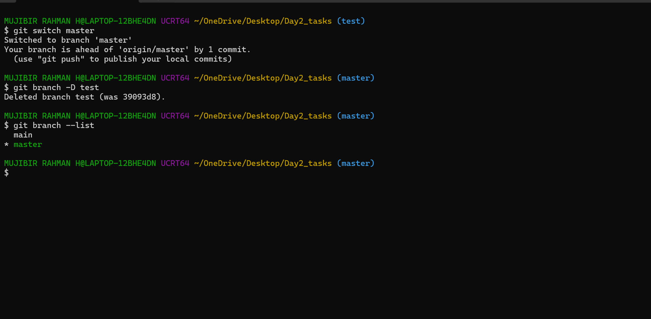
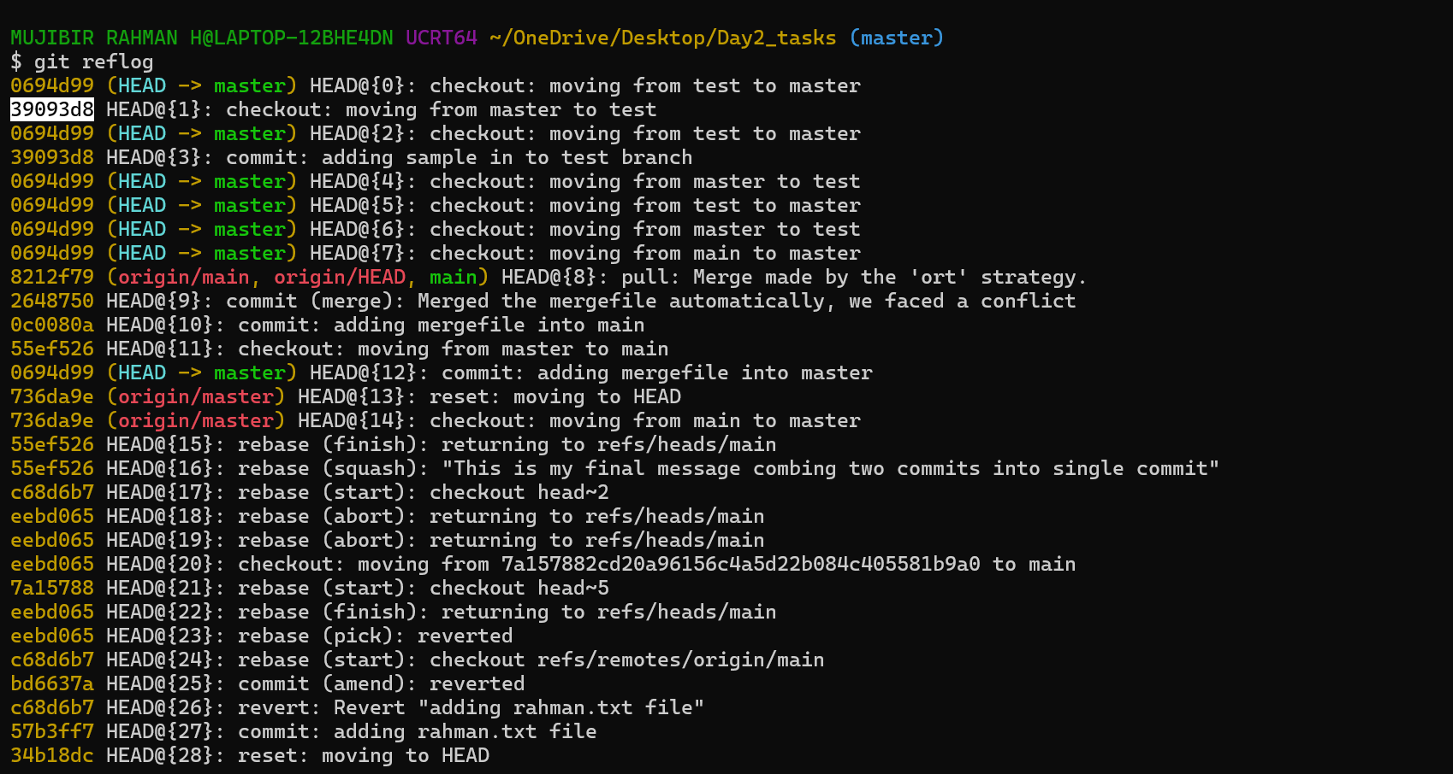
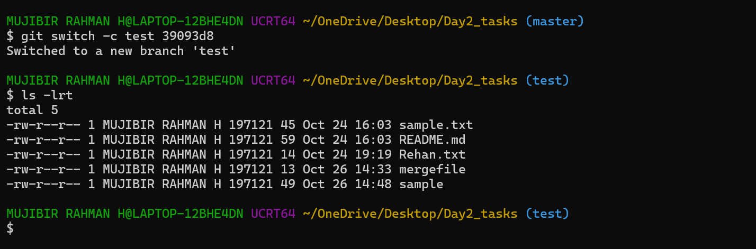
- Undo Wrong Push
  - Push a wrong commit to GitHub, then undo it without losing history.
Solution :
I just added a sample file into test branch
I commited the change already and pushed to github.
So, Now I am just using this – git revert <commit_id of wrong one> .
This process will help us to revert the changes which we made. This will create a new commit id also. It would be really helpful to track a process.
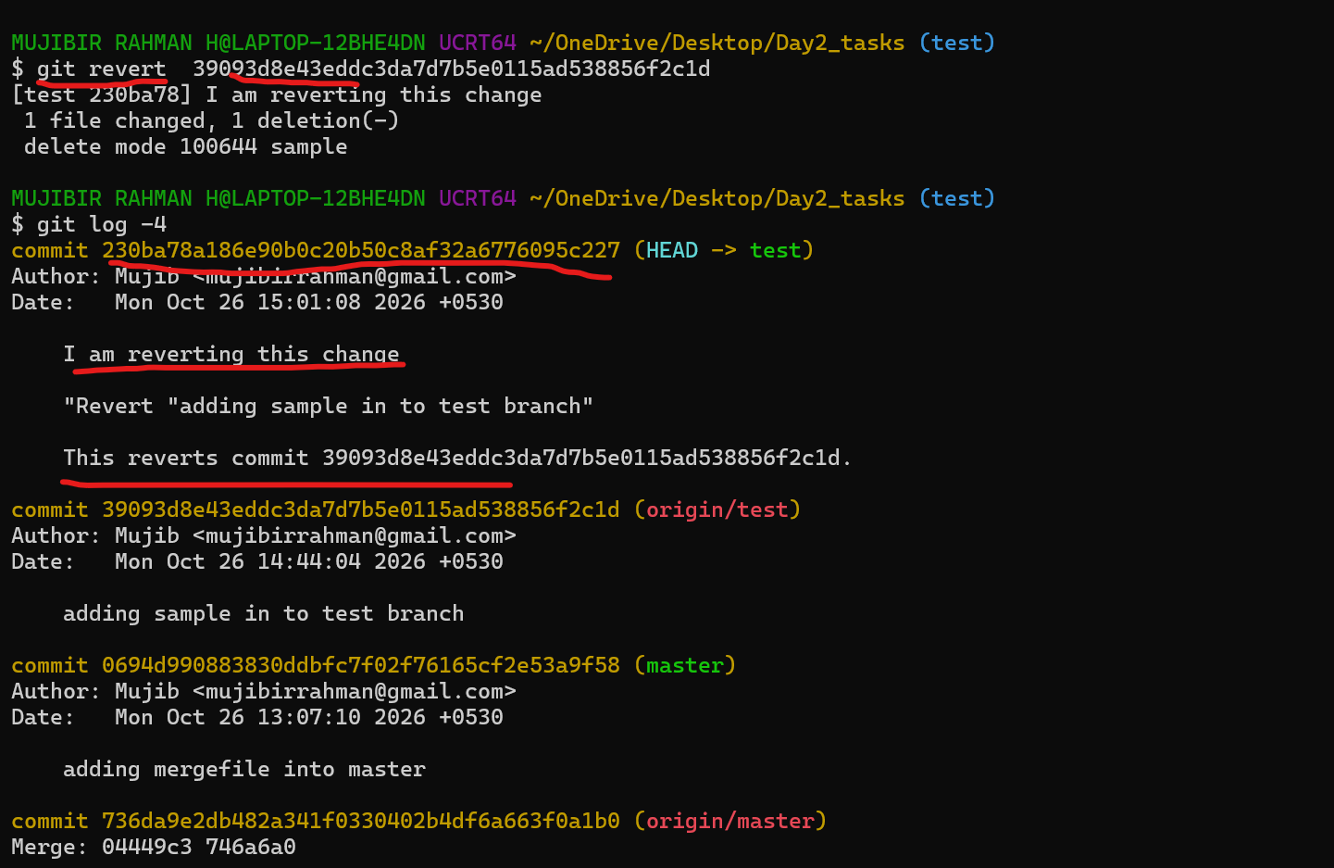
- Amend a Commit
  - Make a commit, then add a missing file to it using git commit --amend.
Solution:
I just created one file and commited that file. (muji is the file name)
I forget to add the second file into the previous commit.
I am just creating second file and I moved that file into tracking process. (rahman is the second file name)
Without creating new commit, we can do commit for second file using below command.
git commit --amend (modify) --no-edit (It’s not changing the old commit message)
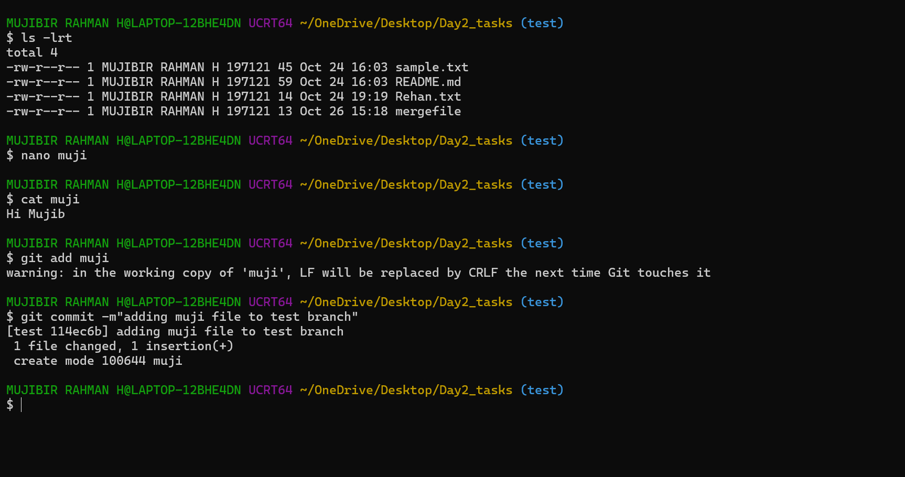
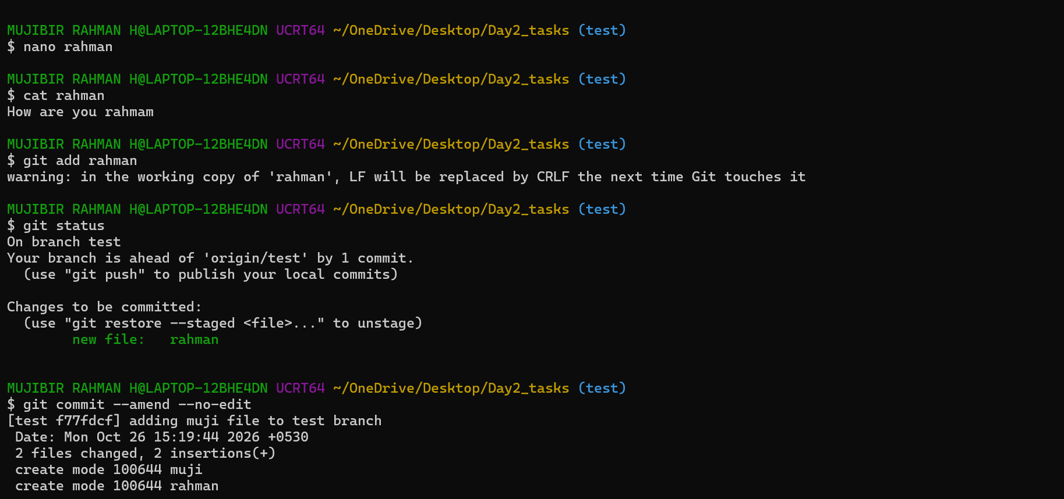
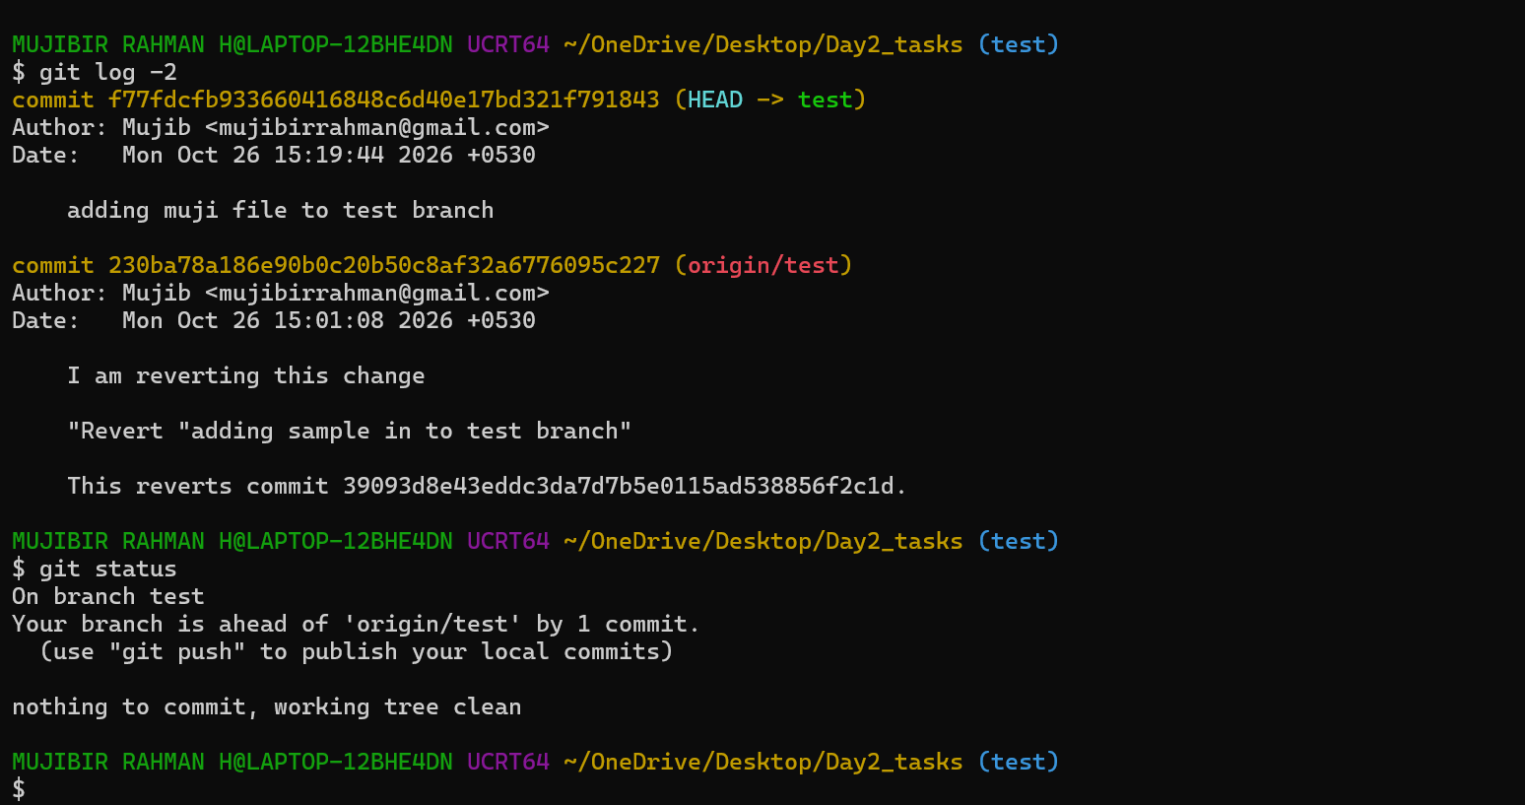
- Cherry-pick a Commit
  - Take a specific commit from one branch and apply it to another branch.
Solution:
cherry-pick command is mainly used for to copy a commit from one branch to different branch.
Here, I just copied a particular sample file from test branch to Mujib branch.
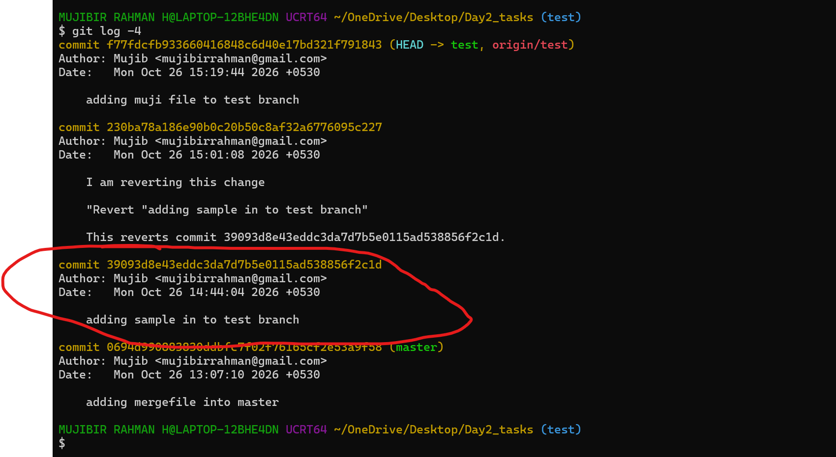
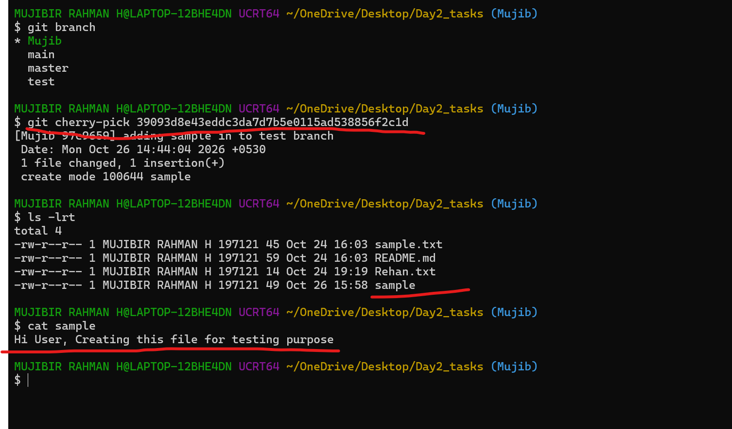
- Interactive Rebase
  - Reorder and squash multiple commits into a single clean commit.
For merging the multiple commit s into single commit using the same command “git rebase -i head~2”
head~2 It’s referring latest two commit ID’s.
I just used the word -- squash -- This word will help/perform for the merging.
(squash meaning - combine)
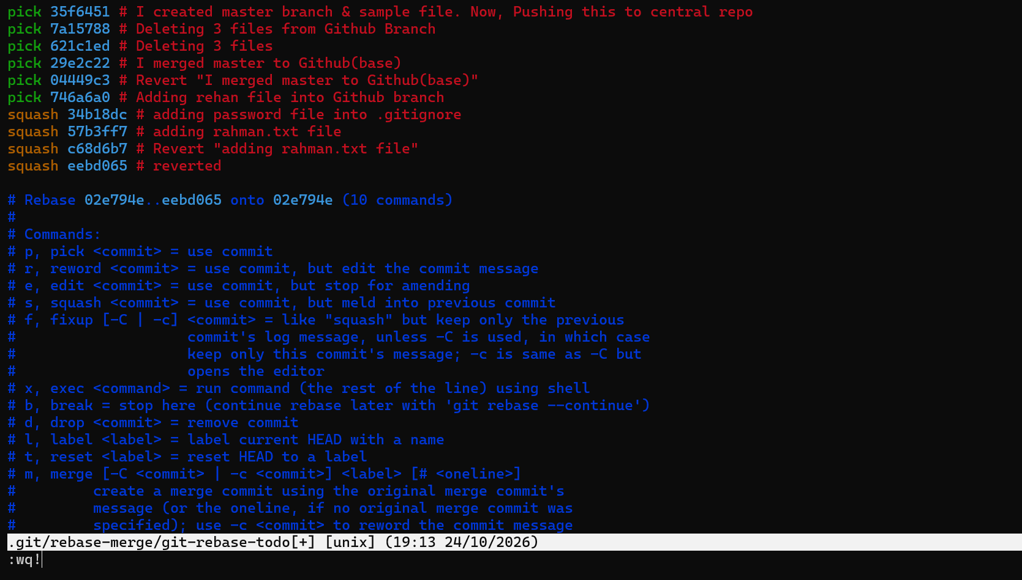
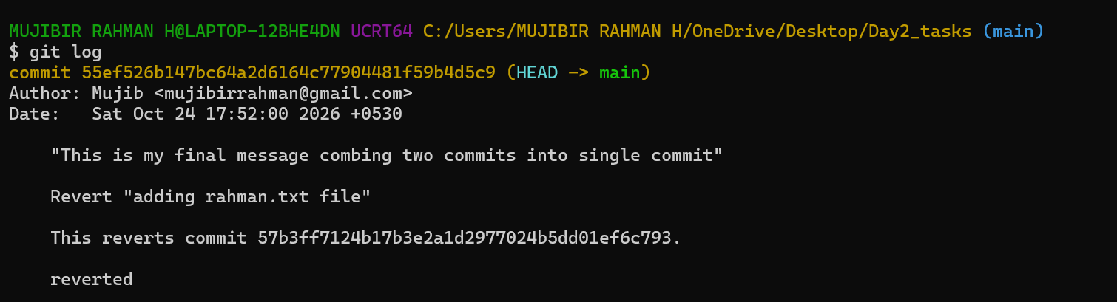
- Tagging & Release
Create a version tag (v1.0), push it to GitHub, then delete and restore it.
Solution:
I am just using the command
git tag -a v1.0 -m “Message”
we can see it’s done or not using - git tag
git show v1.0 will get the details of the tags
After all this, I am just pushing this tag into GitHub repo.
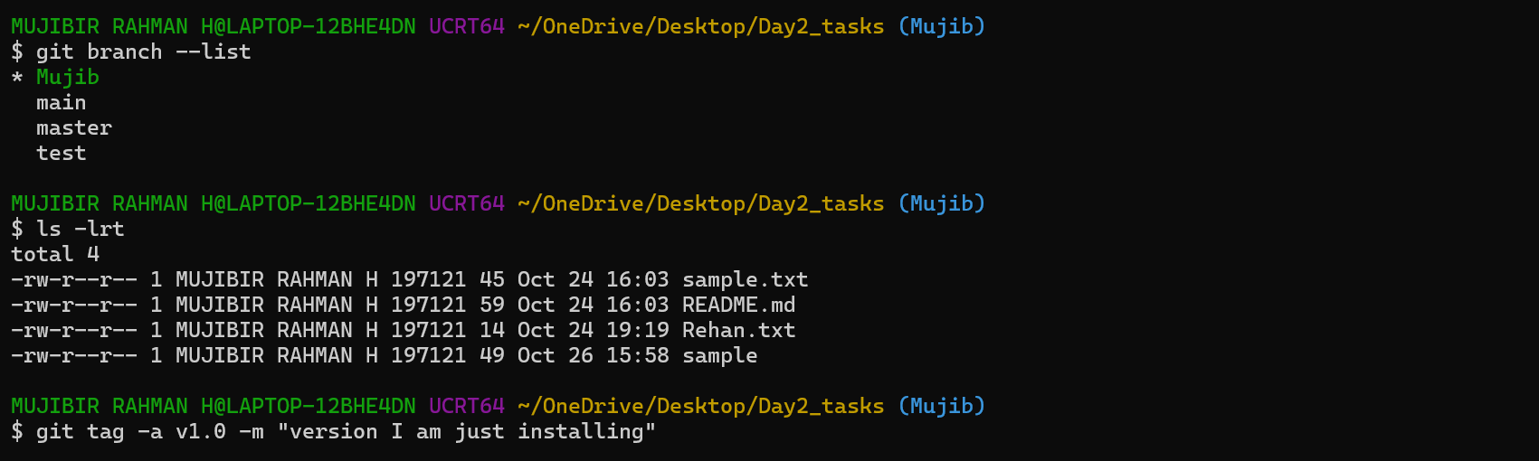
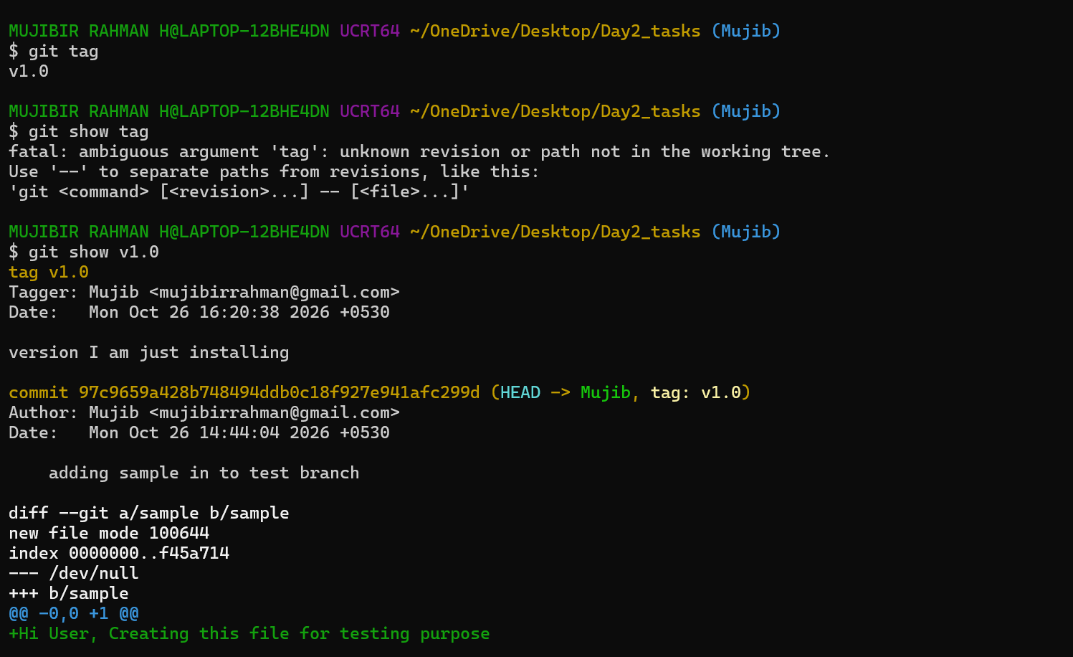
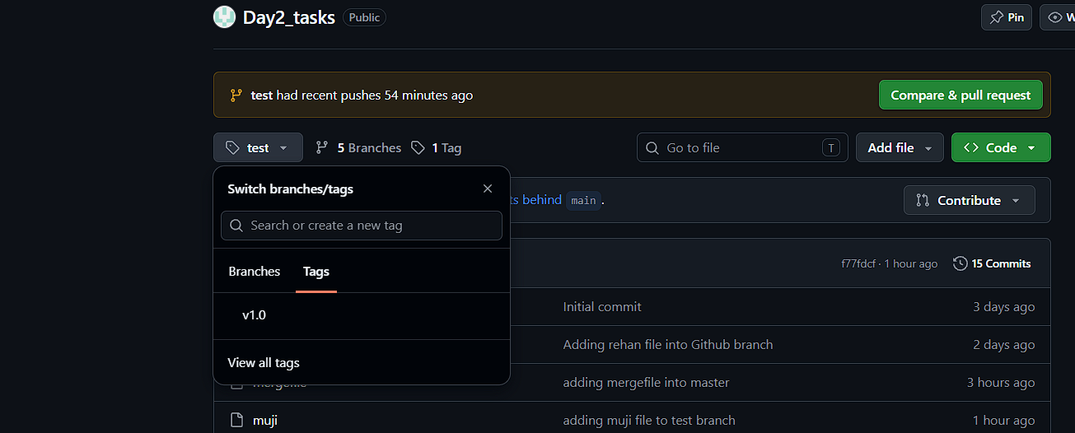
Deletion process:
git tag -d v1.0 – This is the command to delete
After deleting the tag also, we need to push the changes into GitHub.
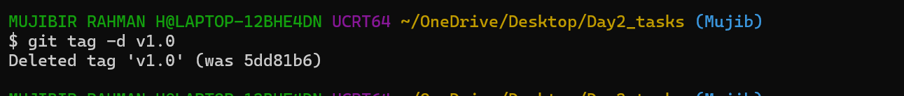
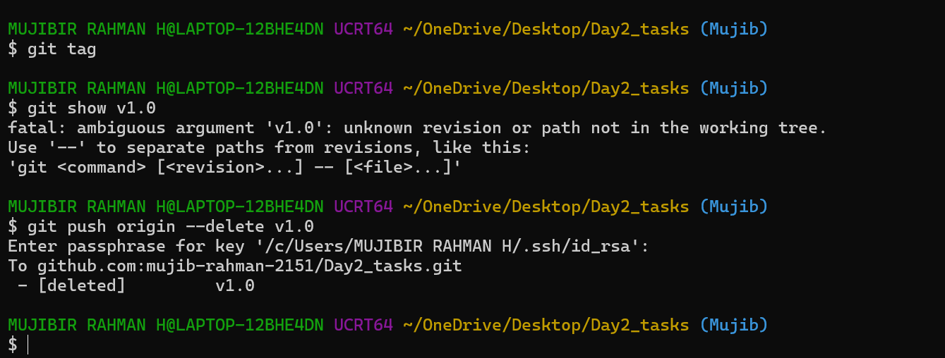
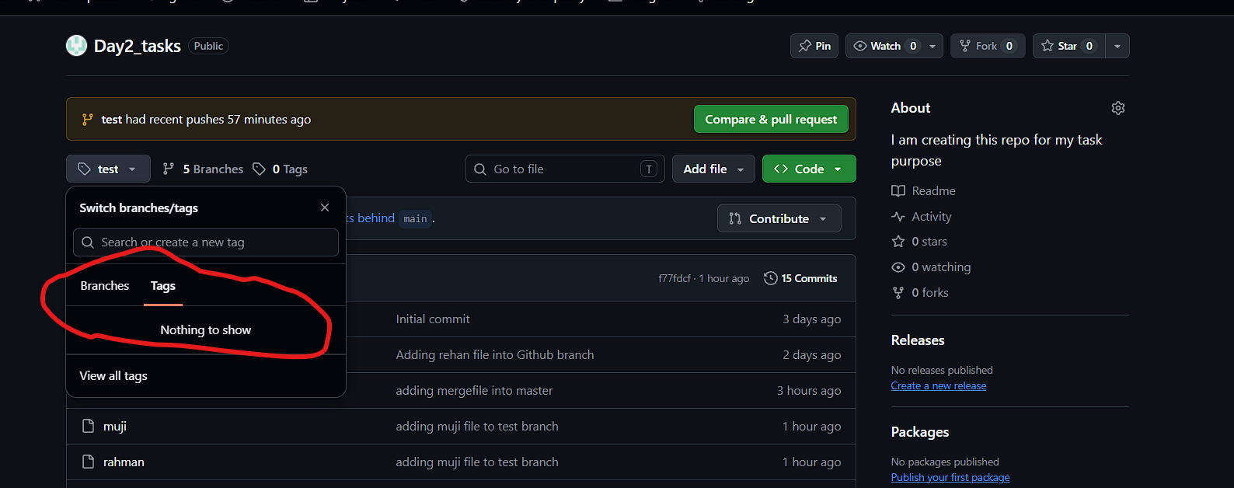
Restoring Process:
After this again we are trying to restore the same tag using below command.
git tag -a v1.0 <commit_id> -m “message”
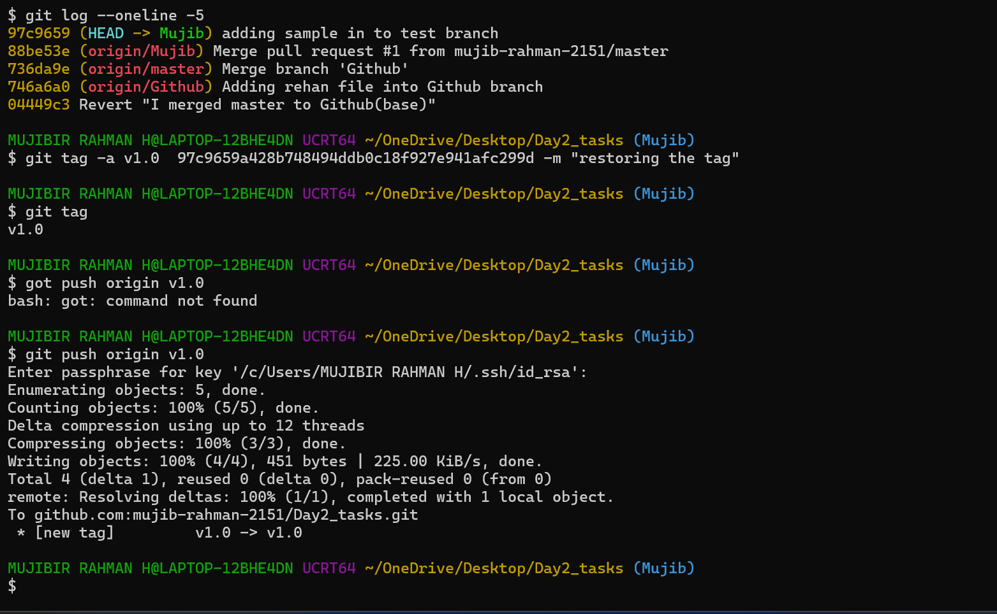
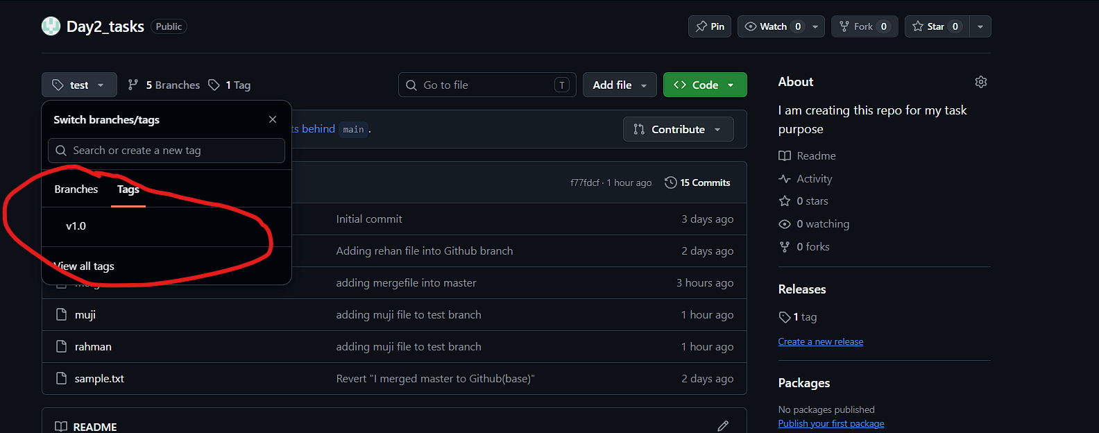
- Clone with Sparse Checkout
  - Clone only a subdirectory of a repo using sparse checkout.
Solution:
Specially, this sparse checkout Is help to clone the sub directories when it is needed.
Usually, will clone the entire thing, That will take much space also so, we can use this sparse- checkout it will help us to save some space.
git clone –filter=blob:none sparse <ssh_link>
--filter-blob:none avoid the downloading all files.
sparse – the word itself will have the answer Meaning – scattered, simple or small in number.
git sparse-checkout set <foldername> using this we can get the particular folder/directory in working place.
If want to add some more directories, We can use
git sparse-checkout add <foldername>
git sparse-checkout list will help us to list out the files what we added.
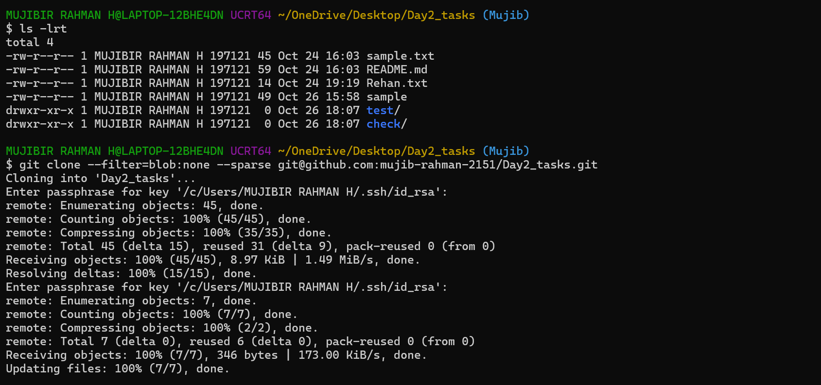
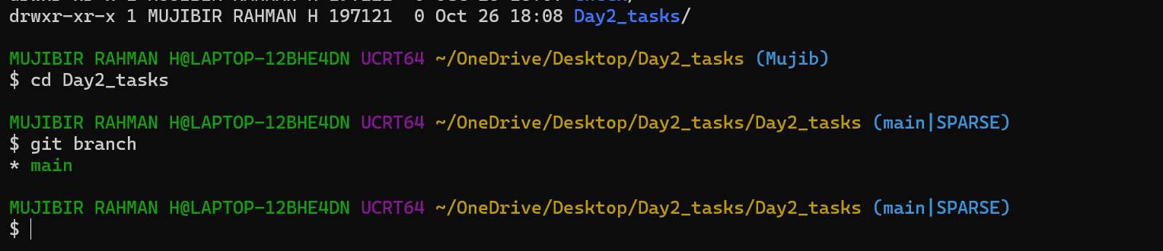
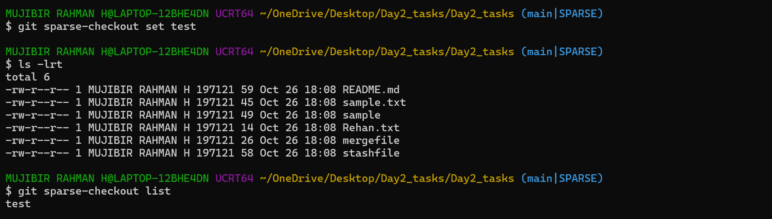
- Reset vs Revert Challenge
- Demonstrate the difference between git reset --hard and git revert in a repo.
git reset :
Will do reset before push the files or code into repo. Once we pushed, We need to revert it. Reset option will not be safe practice and it will affect other’s work.
  - hard makes the staging area and working files match that target commit.
Head -1 It’s indicating the latest commit
Git Revert:
We can revert the changes by using commit ID
This git revert method will generate one new commit again for reverting process. This will help us to track the process.
If someone using the same branch, this changes will not affect them.
- Detached HEAD Challenge
  - Checkout a specific commit (detached HEAD state) and create a new branch from it.
Detached HEAD = directly viewing a specific commit, not standing on a branch. Here, we created a new file from that old commit.
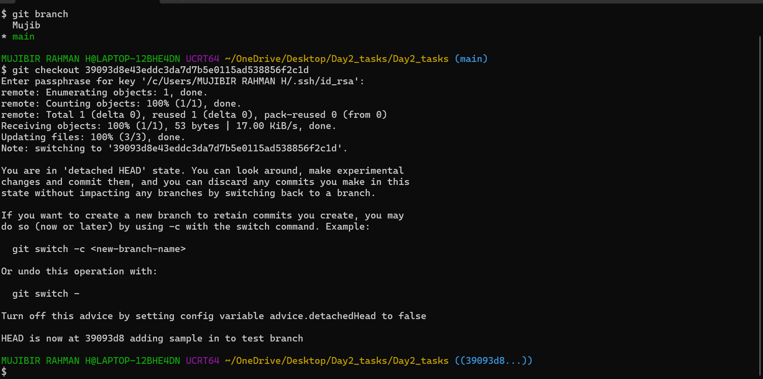
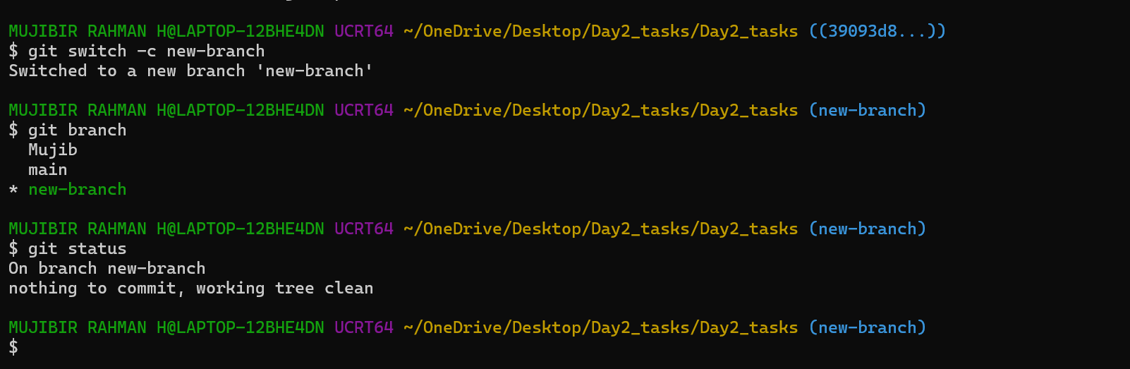
- Git Hooks Challenge
  - Configure a pre-commit hook to reject commits without a message format (e.g., must start with JIRA-XXX).
We automated commit-message checking so developers follow the team's required format before their commits are saved.
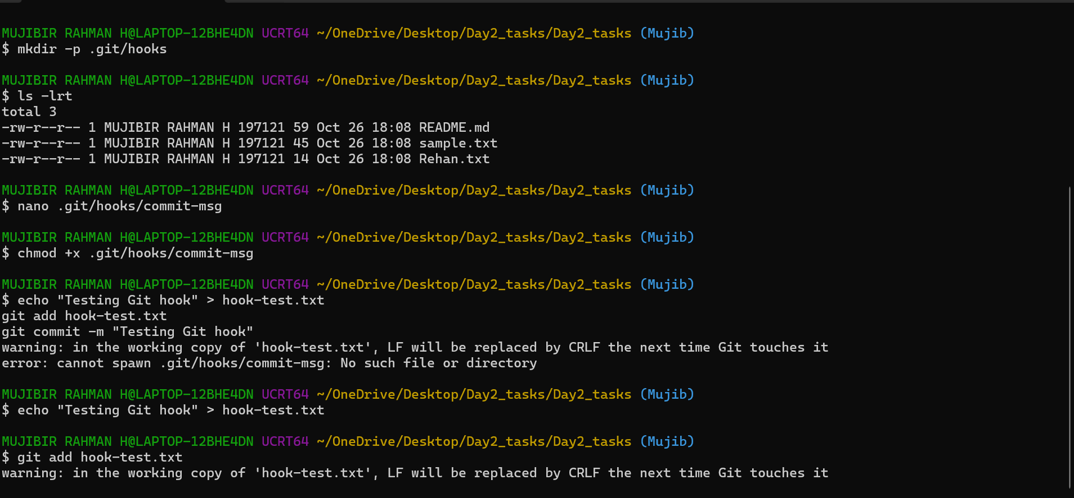
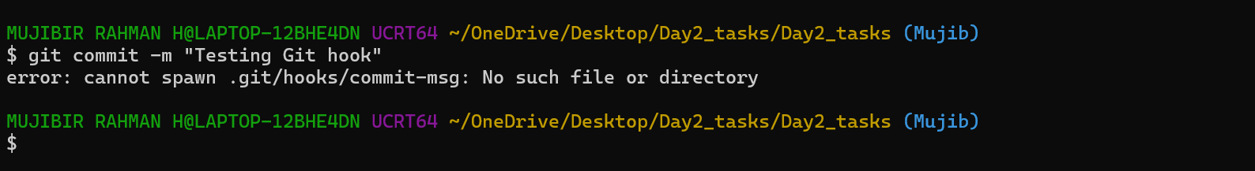
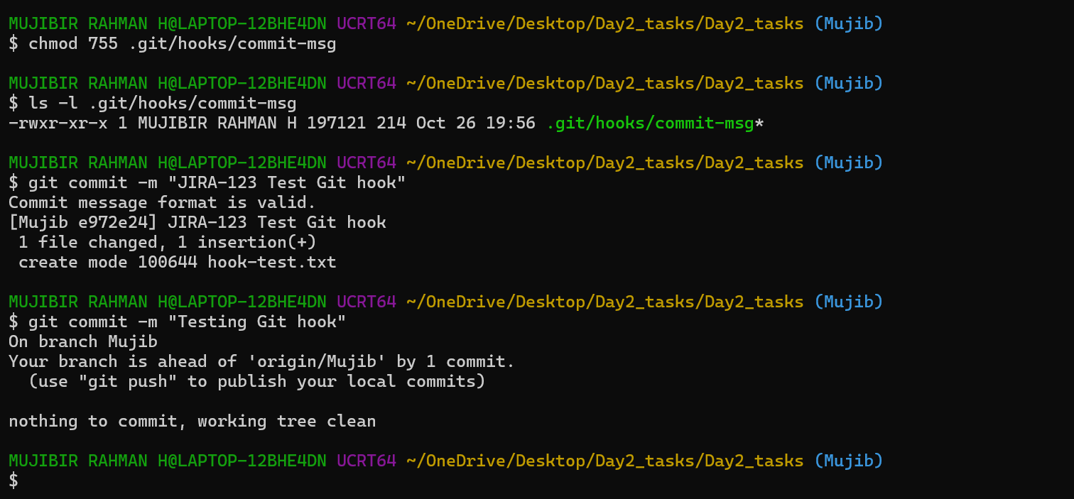
- Squash Merge vs Rebase Merge
  - Show the difference between squash merge and rebase merge with evidence.
Squase Merge:
Combines multiple commits into one single commit.
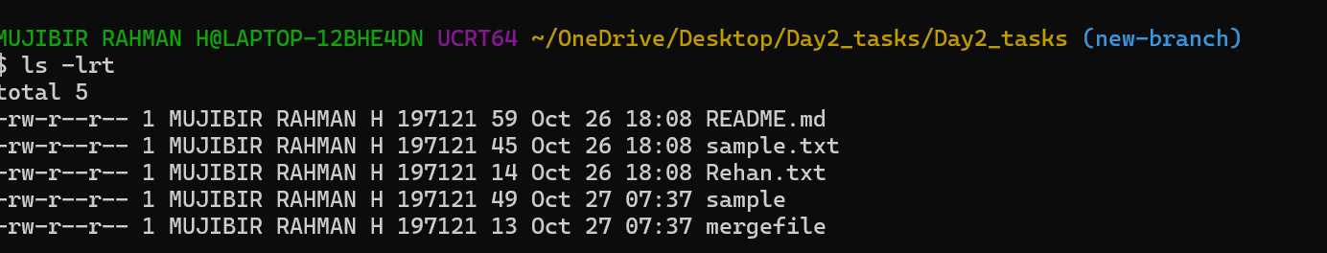
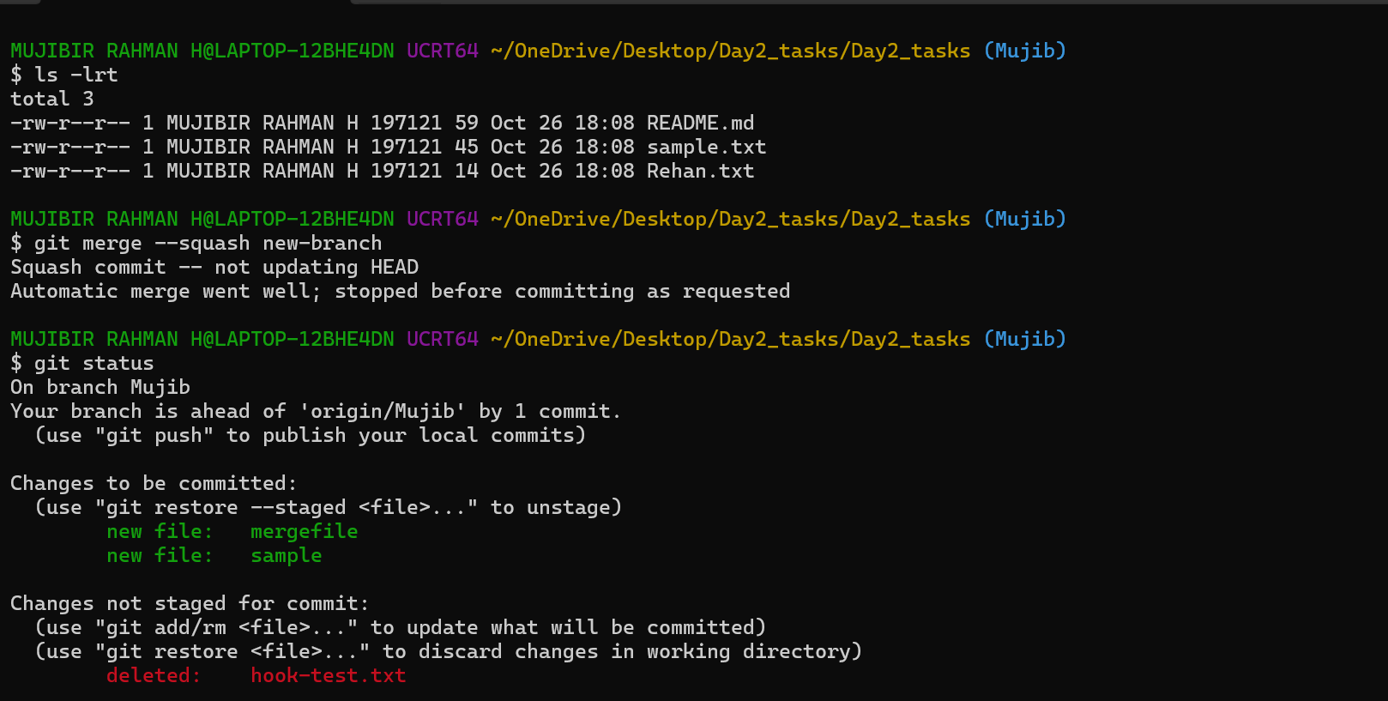
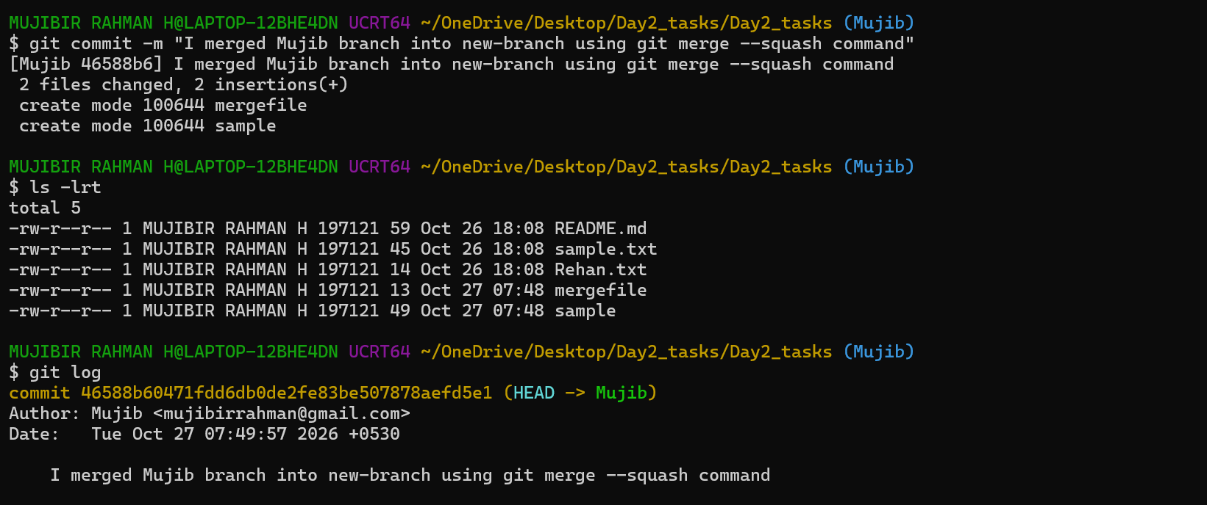
Rebase Merge:
Replays individual commits on top of the target branch to create a linear history, preserving separate commits with new IDs.
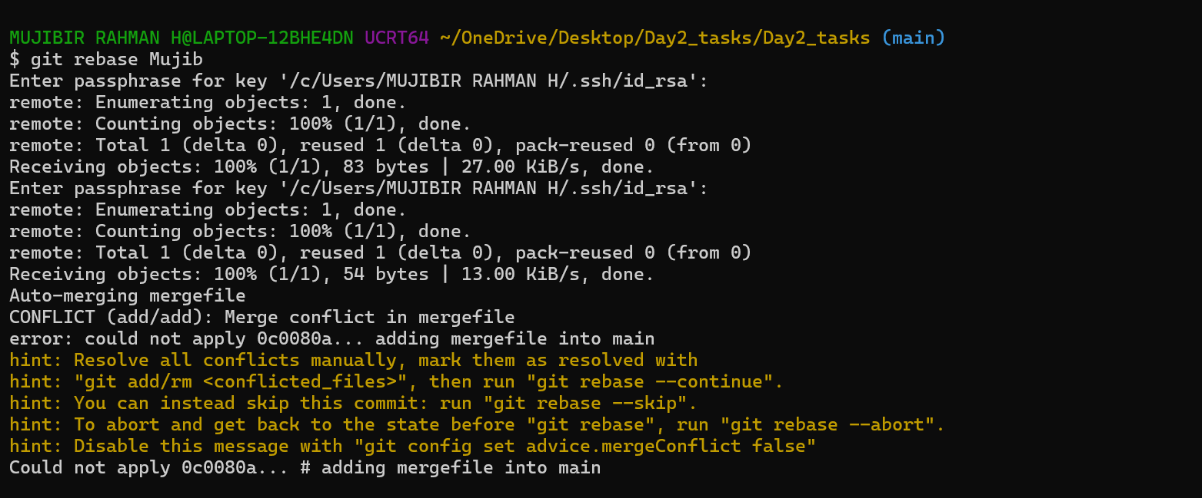
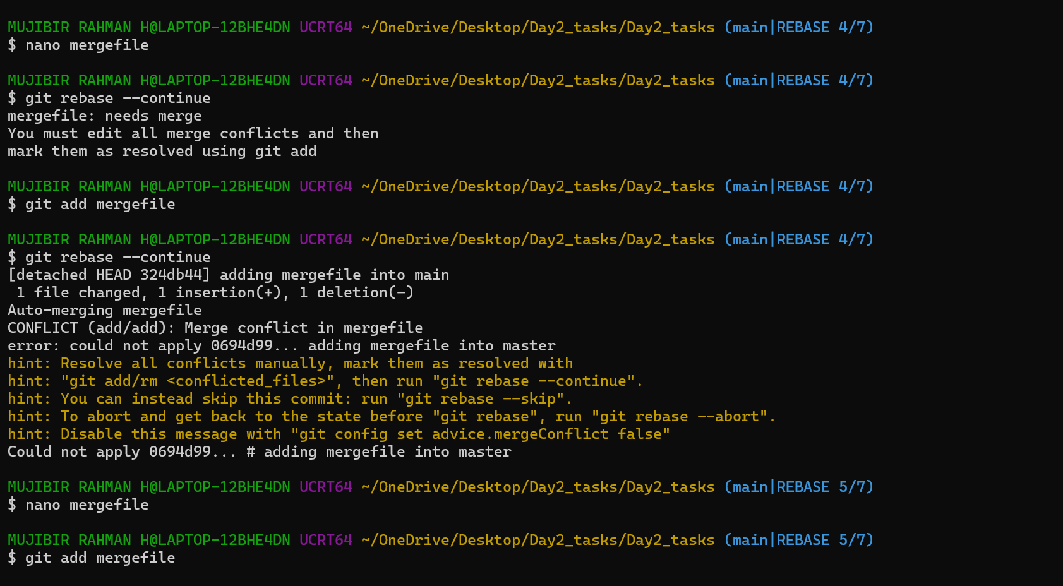
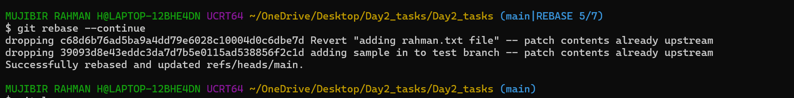
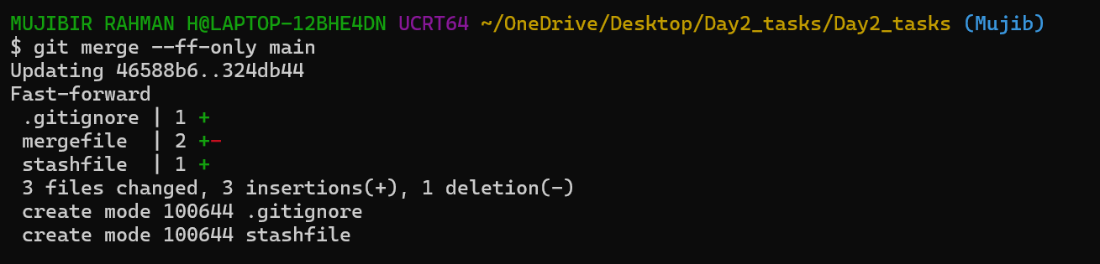
- Fork & Pull Request Workflow
  - Fork a repo, make a change, and submit a pull request to the original repo.
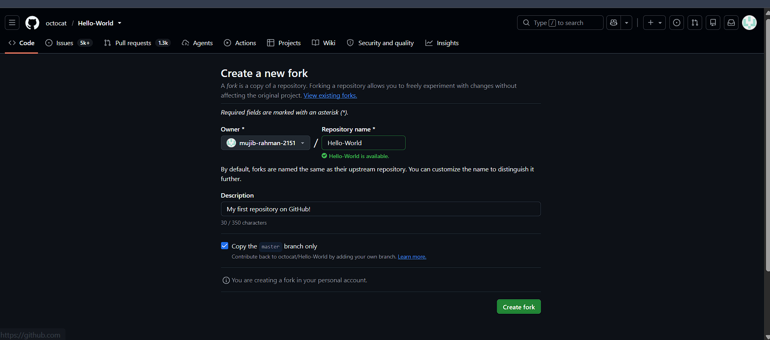
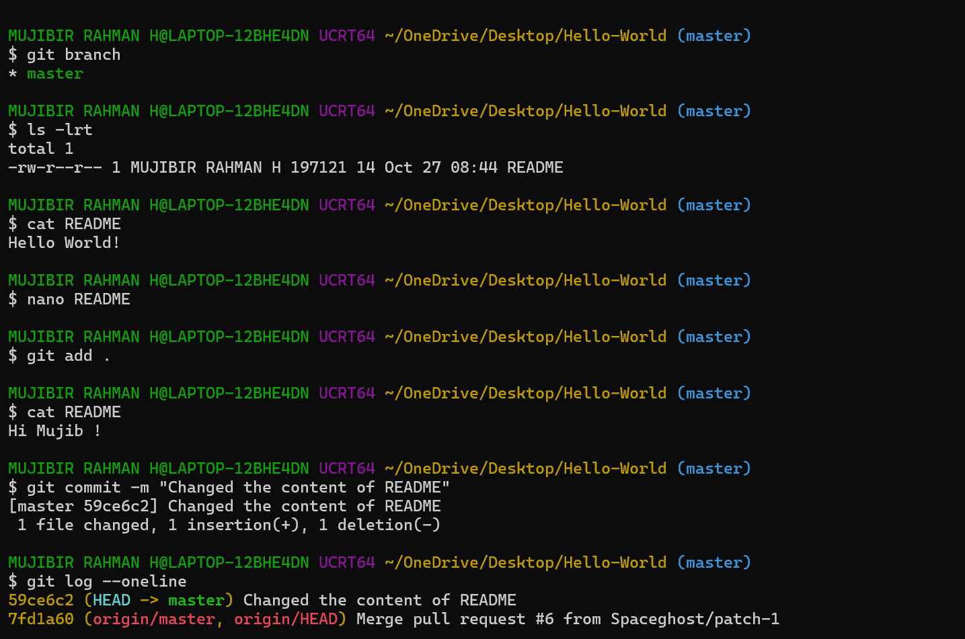
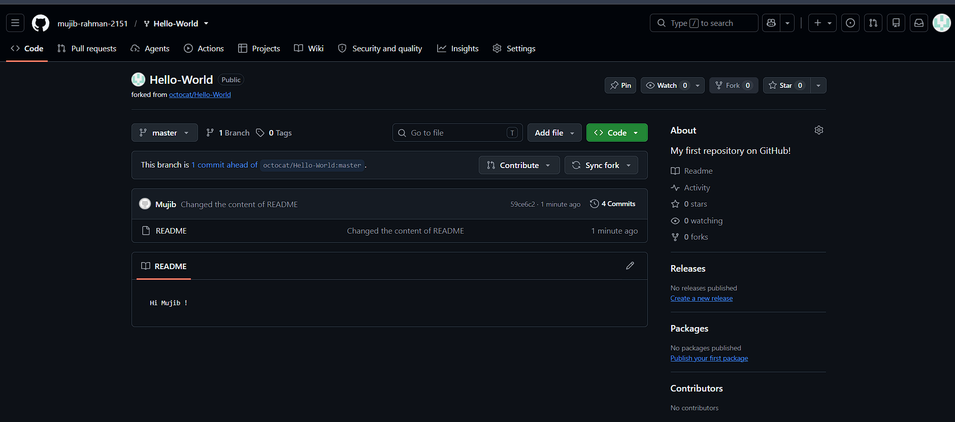
- Recover Lost Commit
  - Commit something, reset hard, and then recover it using git reflog

